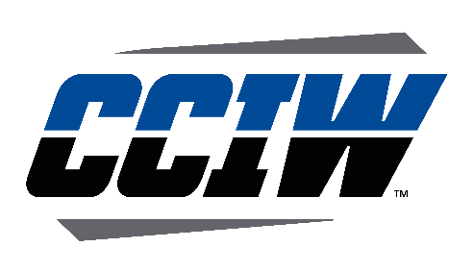
Foreign Tour Certification Checklist

Sport _______________________________________ Dates of Tour __________________________________
Per NCAA Bylaw 17.29.1 a member institution may participate in competition in any sport on foreign tours. The institution must certify in writing that all NCAA bylaws are met and must maintain the certification on file in the athletics department.
Contest or dates of competition on a certified foreign tour shall be excluded from contest limitations (Bylaw 17.29.1.1).
Opponents: A tour to a U.S. commonwealth or a U.S. territory, is not considered a foreign tour (Bylaw 17.29.1.2). Institutions shall not compete against other American teams other than teams composed of U.S. armed forces personnel stationed at U.S. military bases in foreign countries (Bylaw 17.29.1.8).
Timing of Tour: Foreign tours must take place during a published vacation period, including all travel to and from (Bylaw 17.29.1.3). An institution may participate in a foreign tour in each sport once every three years. (Bylaw 17.29.1.4).

Dates of published vacation period ______________________________________

Previous Tour ______________________________________________________

Eligibility for a Foreign Tour: All student-athletes must have been eligible during the previous academic year or shall have been enrolled as a full-time student during the previous academic year and have established that they are eligible for competition the next academic year (summer tours); or the student-athletes shall be regularly enrolled in the institution and eligible for intercollegiate competition (academic year tours) (Bylaw 17.29.1.5). Incoming student-athletes are not eligible for a foreign tour until after the first date of practice or first day of classes, whichever comes first (Bylaw 17.29.1.5.1).

Date student-athletes were certified for the foreign tour ___________________________

Practice: Institutions may engage in 10 days of practice before departure of a foreign tour. (17.29.1.6)

Dates of Practice _________________________________________________________

Competition: An institution is limited to a maximum of three football games, 10 basketball games or 10 contests or dates of competition in other sports (Bylaw 17.29.1.7)

Dates of Competition ______________________________________________________

Expenses: Per Diem-$30 per day to cover unitemized incidental expenses for a maximum of 21 days (Bylaw 17.29.1.9.1).
Transportation- No transportation expenses to return home for a student-athlete who remains in the foreign country after the foreign tour is completed (Bylaw 17.29.1.9.2).
Passports- Permissible to provide to student-athletes when required for foreign tour travel (Bylaw 17.29.1.9.3).

The above tour has been certified.

__________________________________________ __________ ___________________________________
Signature Date

__________________________________________ __________ ___________________________________
Print Name Title

